Pattern Predictor

Pattern Predictors

Activity Overview
Students explore how predictions improve with more data through a bus arrival prediction scenario.
Learning Objective  Students understand how predictions improve with richer data sets. | Standards & Competencies  - 1b (Understand Mechanics of AI)  - 2b (Examine outputs)  - CCSS.Math.Practice.MP7: Look for and make use of structure
Materials  - Calendar cards  - Recording sheets | Preparation  - Prepare calendar cards and recording sheets.

Launch (4-5 minutes)
Slide | Exploration Guide
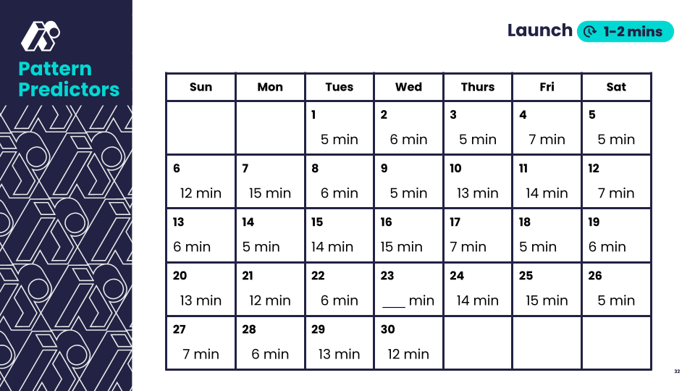 | Say: "What do you notice? What do you wonder?”  Students quickly share noticings and wonderings.
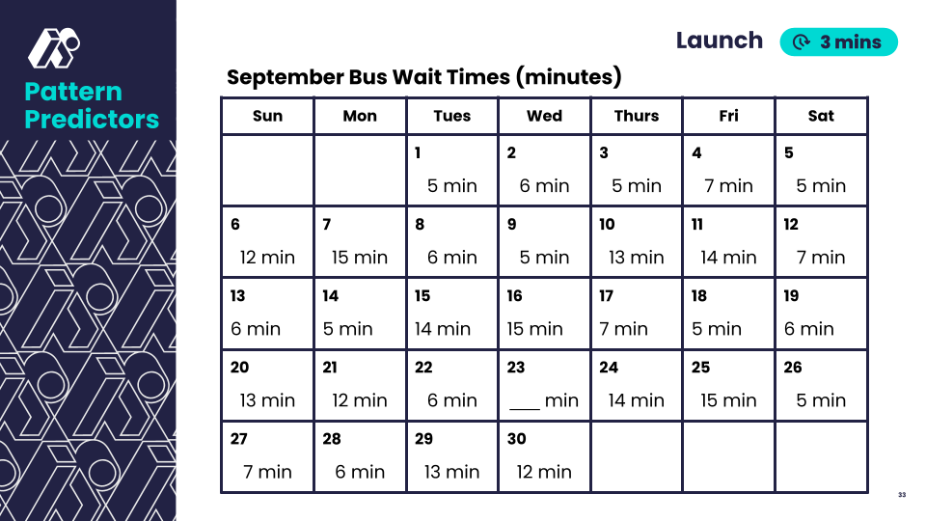 | Say: "What do you notice now? What do you wonder?”  Students quickly share noticings and wonderings.  Say: “What could be affecting the bus times?"  Look For:  - Students identify multiple factors that could have also affect bus waiting times (regular driver out sick, road accidents, construction, etc)  Say: “Predict the wait time on the missing date. How confident are you in your prediction?"  Students think-pair-share predictions.
💡Teaching Tip: Have students use hand signals to show confidence levels (e.g., show 1-5 fingers)

Play (8-9 minutes)
Slide | Exploration Guide
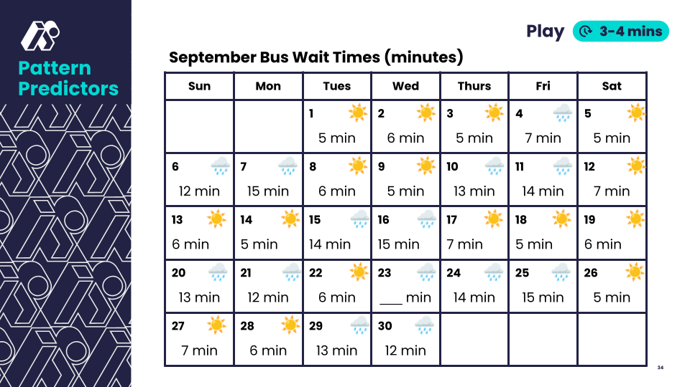 | Say: "What do you notice? What do you wonder?”  Students quickly share noticings and wonderings.  Say: "Would you change your prediction? How confident are you in your prediction now?"  Students share predictions and confidence levels with their thumbs.  Look For:  - Students notice that longer wait times tend to happen on rainy days.  Common Student Misconceptions:  - Longer wait times definitely happened because of the weather.  - Response: What else could have caused longer bus wait times?
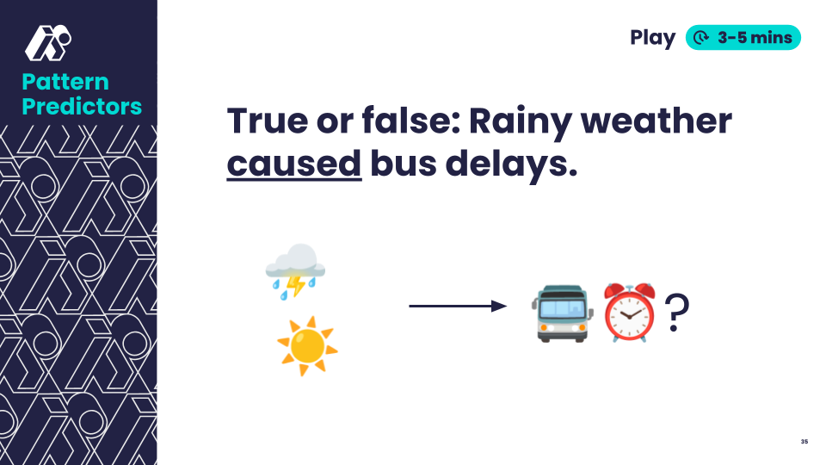 | Say: "Can we be 100% sure that the rainy weather caused the bus delays? What else might affect bus times?"  Students think independently for 1 minute, then share.  Look For:  - Students identify multiple factors that could have also affect bus waiting times (regular driver out sick, road accidents, construction, etc)  - Recognize that they need more data to be able to confidently say that the rain causes longer wait times.
💡Teaching Tip: Provide students recording sheets to help organize their thinking.

Land (3-6 minutes)
Slide | Exploration Guide
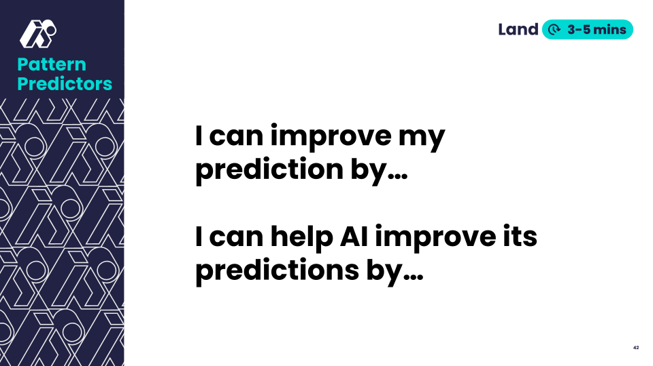 | Say: "How can you improve your prediction? What can help AI make better predictions?"  Look For:  - AI and humans both need data/examples to make good predictions  - AI can process much more data than humans can  - More data can help make better predictions, but sometimes there are other factors or causes that we can’t see (like accidents, construction, or late bus drivers!)  Common Student Misconceptions:  - More data always leads to better predictions.  - Response: Sometimes data can have errors or can be misleading.
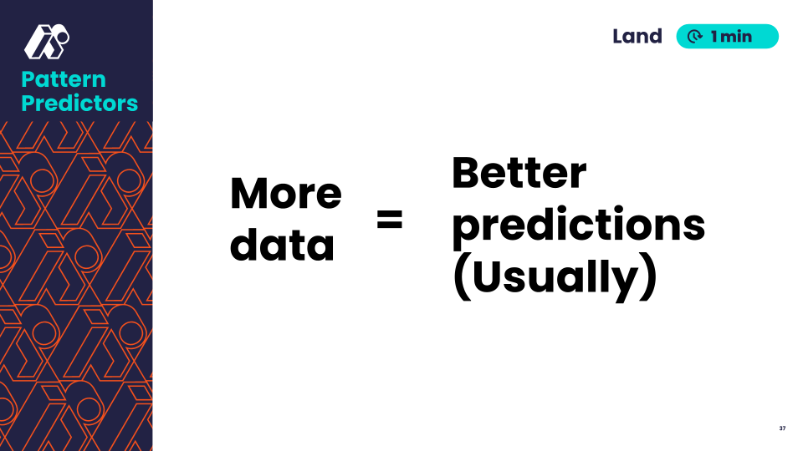 | Say: "Remember: more data usually leads to better predictions. "
💡Teaching Tip: Make student thinking visible by displaying in a T-chart or idea web.

